

Ormesby Village Infant & Junior Schools Federation
Headteacher: Mr. Bradley Young

Ormesby Village Infant School Ormesby Village Junior School
Spruce Avenue, Ormesby St. Margaret North Road, Ormesby St. Margaret, Great
Great Yarmouth, Norfolk, NR29 3RY Yarmouth, Norfolk, NR29 3LA
Telephone: (01493) 730298 Fax: (01493) 733810 Telephone: (01493) 730944
Email: office@ormesbyinfant.norfolk.sch.uk Email: office@ormesbyjunior.norfolk.sch.uk
Website: www.ormesbyinfant.norfolk.sch.uk Website: www.ormesbyjunior.norfolk.sch.uk
Dear Parents/Carers, 21.10.25

I am pleased to inform you that on Friday 21st November 2025, our Junior school choir will be attending the Great Yarmouth Minster to sing some seasonal songs amongst other schools as part of their Christmas Fayre programme on its opening day. Mrs. White-Joubert will accompany the children on the day to ensure everything runs smoothly. This is a public event, so anybody is able to attend and peruse the stalls that will be open.

The time slot allocated for the choir’s performance is 10.40 – 10.55 am.

The children will be travelling to Great Yarmouth by coach and will leave school at approximately 10:00am and will return in time for lunch.

The cost of the trip will be £6.00 per child and for those in receipt of Pupil Premium the cost will be £3.00.
All payments to be made via IRISParentMail under the tab Great Yarmouth Minster.
The last date for payment is Thursday 13th November 2025.
Please be advised that without sufficient contributions the trip will not go ahead.

Please send your child into school on that day dressed in their school uniform and ensure they bring their water bottles with them.

Please complete both the consent form and slip below, returning both to the Office by Thursday 13th November 2025.

Yours sincerely,

Mr. B. Young
Headteacher
_______________________________________________________________________________________

To Mr. Young,
Minster Choir Trip 21.11.25

I give / do not give (delete as appropriate) permission for my child __________________________
to take part in the Choir Trip to the Minster on Friday 21st November 2025 and agree to pay the appropriate amount by
Thursday 13th November 2025.


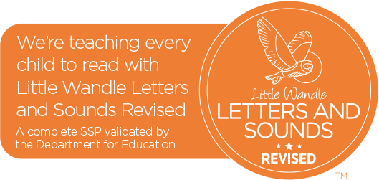



Signed: ____________________________________

