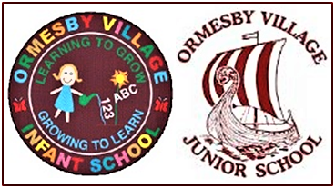

Ormesby Village Infant & Junior Schools Federation
Headteacher: Mr. Bradley Young

Ormesby Village Infant School Ormesby Village Junior School
Spruce Avenue, Ormesby St. Margaret North Road, Ormesby St. Margaret, Great
Great Yarmouth, Norfolk, NR29 3RY Yarmouth, Norfolk, NR29 3LA
Telephone: (01493) 730298 Fax: (01493) 733810 Telephone: (01493) 730944
Email: office@ormesbyinfant.norfolk.sch.uk Email: office@ormesbyjunior.norfolk.sch.uk
Website: www.ormesbyinfant.norfolk.sch.uk Website: www.ormesbyjunior.norfolk.sch.uk

Dear Parents/Carers, 7.11.25

School Calendar Dates 2026-2027

The Norfolk County Council Model Calendar is a document on which most schools base their academic year and it is a calendar, which enables NCC school transport to run smoothly. Schools must ensure there are 190 teaching days and 5 INSET (staff training) days annually.

Next academic year during 2026-2027, it seems the model calendar wishes most schools to finish on Wednesday 21st July 2027. Our Federation feels this would be detrimental to our curriculum delivery ending on a broken week. As a result, our Governors have agreed to a calendar alteration to enable our schools across the Federation to end the academic year on Friday 16th July 2027 instead. This will mean our schools must be open on three other days earlier in the year, when some schools are planned to be closed.

Therefore, our Infant and Junior Schools will be open on Friday 23rd October 2026 (The Friday before October half-term 2026), on Monday 4th January 2027 (Day the children return after the Christmas holidays 2026) and on Monday 12th April 2027 (Day the children return after the Easter holidays 2027). Both schools will finish the academic year 2026-2027 at the end of the day on Friday 16th July 2027.

Thank you for your continued support and understanding.

Yours sincerely,

Bradley Young
Headteacher

